Emergency Business
Continuity Plan 2022
NSW SES Emergency Business Continuity Plan
BUSINESS NAME: Taree Basketball
PREPARE
Get ready for natural disasters with these five simple steps:
- KNOW YOUR RISK
  - Think about the area you live in and how natural disasters could affect you and your business.
- PLAN NOW FOR WHAT YOU WILL DO
  - Make an Emergency Business Continuity Plan.
- PREPARE YOUR BUSINESS
  - Clean your gutters, trim trees, store loose items, maintain your business premises, check your insurance policy and ensure you have an Emergency Kit prepared.
- BE AWARE
  - Stay informed on how to prepare and what to do if there is a natural disaster in your area.
- LOOK OUT FOR EACH OTHER
  - Share information with employees. Delegate tasks appropriately to staff members in the event of a natural disaster. Practise your plan.
IDENTIFIED RISKS
You have identified you are at risk of:
- Storm
- Building fire
- Flash floods
- Floods
These hazards can have devastating impact on people, property and possessions.
Even if you are not directly impacted upon, you may still be affected by these events as roads may be damaged, access to areas may be restricted, services may be lost, you may become isolated, areas you are planning to travel to may be impacted and family, friends or employees may be affected.

WARNINGS AND INFORMATION
For information on weather warnings visit the Bureau of Meteorology at www.bom.gov.au.
For information on Flood, Storm and Tsunami visit NSW State Emergency Services at www.ses.nsw.gov.au .
Visit Mid-coast Council website http://www.midcoast.nsw.gov.au
for flood plans and other information.
Listen to your Local Radio stations for weather warnings.
ABC MID-NTH COAST 684 AM, 756 AM
2BOB 104.7 FM
2MC FM 100.7 FM, 106.7 FM
2WAY 103.9 FM
GREAT LAKES 101.5 FM
MAX 107.3 FM
For more emergency information, advice, and access to the latest river heights and rainfall observations and forecasts:
* RMS Live Traffic: www.livetraffic.com
* Latest River Heights and Rainfall Observations: www.bom.gov.au/nsw/flood/midnorth.shtml
* Latest NSW Warnings: www.bom.gov.au/nsw/warnings/
* Rainfall Forecasts: www.bom.gov.au/australia/meteye/
* BOM NSW Twitter: www.twitter.com/BOM_NSW

KNOW YOUR RISK
Know your storm risk
Storms can happen anywhere, at any time of the year. During storms it is important to protect your business from the major impacts such as strong winds, hail and rising water levels (flash flooding).

- Damaging winds can bring down trees, branches, and power lines, remove roofs and blow around outdoor items
- Hail can injure people and damage property
- Heavy rainfall can cause water to
- Damage exposed buildings and property
- Rise rapidly, flooding businesses, property and roads
- Drain rapidly making floodwaters, drains and other watercourses a safety hazard
- Damaging surf can be unsafe and flood premises and properties in coastal areas
- You may also be indirectly affected by storms; access roads may be blocked or you have no power, utilities or telephone connection
- Visit the NSW SES StormSafe website www.stormsafe.com.au for StormSafe information and read the StormSafe Guide
- Talk with other business owner and people who have worked in the area for a while about the local storm history

Know your flood risk
Floods can affect areas across the country although some areas are more susceptible than others. Flood histories can be indicative of the likelihood of flood in your area. Knowing the history of floods where your business is located can assist in preparing and planning for flood – it could indicate levels, frequency and drainage patterns. Talk with other business owners and people who have worked in the area for a while about the local flood history or contact your local council for flood plans for your area and associated histories.

- Find out about your local flood history and visit the NSW SES FloodSafe website www.floodsafe.com.au and read the FloodSafe Guides relevant to your area

- Talk with other business owners and people who have worked in the area for a while about the local flood history
- Know the heights your area is affected by floods. Mid-coast Council may be able to provide you with specific information on how floods affect your property
- Be aware of the natural signs of flooding such as heavy rainfall and rushing or pooling water

Know your Structural and Urban fire risk
Fires can affect any business and can have a significant risk to life and cause property damage. Electrical goods, flammable materials, heat sources can increase the likelihood of starting a fire.
People may be a greater risk from fire in your premises if you do not have a working smoke alarm, working fire-extinguishing equipment, rehearsed and understood evacuation plans.

- Visit the NSW Fire and Rescue website at www.frnsw.nsw.gov.au
Other Risks:
For information on earthquakes, heat waves and other disasters, visit the Australian Emergency Management Institute www.em.gov.au
TRIGGERS AND ACTIONS TO TAKE
Triggers are those identified signs that indicate to a business that they need to start preparing for a disaster or for evacuation.

Triggers | Your Business Action
Storms/Cyclones/Coastal Inundation  Severe Weather or Thunderstorm Warning  (BoM) with:  - High winds  - Heavy rainfall  - Flash flood  - Hail | - Ensure outside items are brought inside or tied down  - Avoid drains or waterways  - Avoid low-lying areas  - Move vehicles undercover
Floods  Flood Watch or Flood Warnings  (see below for further details) | - Listen to your local radio station for information, updates and advice  - Advise users and staff when the site is shut due to flooding risk  - Advise users and staff to never drive, ride or walk through floodwater - this is the main cause of death during floods as water may be deeper or faster flowing than people think and contain hidden snags and debris  - Secure objects that are likely to float and cause damage  - Locate important papers, valuables and mementoes. Put them in your Emergency Kit and take them with you if you need to evacuate.  - Relocate waste containers, chemicals and poisons well above floor level  - Turn off the electricity and gas at the mains before you leave and turn off and secure any gas bottles  - Keep listening to a local radio station for further information, updates and advice  - Raise stock and electrical items from floor to appropriate height  - Be prepared to evacuate
Structural Fires  Smoke Alarm Sounds  See a fire (which is manageable)  www.fire.nsw.gov.au | Evacuate  Use appropriate equipment to put out if it is safe to do so and the person is trained
July School Holidays | Check outside of building for debris, and dead branches

In relation to flooding, the category of flood warning will assist in identifying the appropriate actions to take. The three categories are:
Minor flooding
Flooding which causes inconvenience such as closing of minor roads and the submergence of low-level bridges. The lower limit of this class of flooding is the initial flood level at which landholders and/or townspeople begin to be affected in a significant manner that requires the issuing of a public flood warning by the Australian Government Bureau of Meteorology.
Moderate flooding
Flooding which inundates low-lying areas, requiring removal of stock and/or evacuation of some houses. Main traffic routes may be flooded.
Major flooding
Flooding which causes inundation of extensive rural areas, with properties, villages and towns isolated and/or appreciable urban areas flooded.
In relation to flooding, the BOM website identifies the following flood levels for the Manning River in relation to these categories:
- Minor Flooding: 1.80m
- Moderate Flooding : 2.40m
- Major Flooding : 3.70m
The trigger for evacuation or notification for the site to close to users will be when there is a flood predicted at or higher than the minor flooding level of 1.80m
Business Actions regarding securing the site will be implemented if it is safe to access the site. These actions would need to be implemented prior to any flooding exceeding the minor flood warning level of 1.80m.

EVACUATION PLAN
The site would be closed the site at times were flooding is predicted, and staff and users will be notified to not attend the site.
If significant flooding has already occurred when the site is operational and it is not safe to leave the site, stay in place and seek advice from emergency services.
Should a flooding event occur when the site is operational, as indicated in Figure 1 below, land not identified as flood prone is located within a short walk from the site
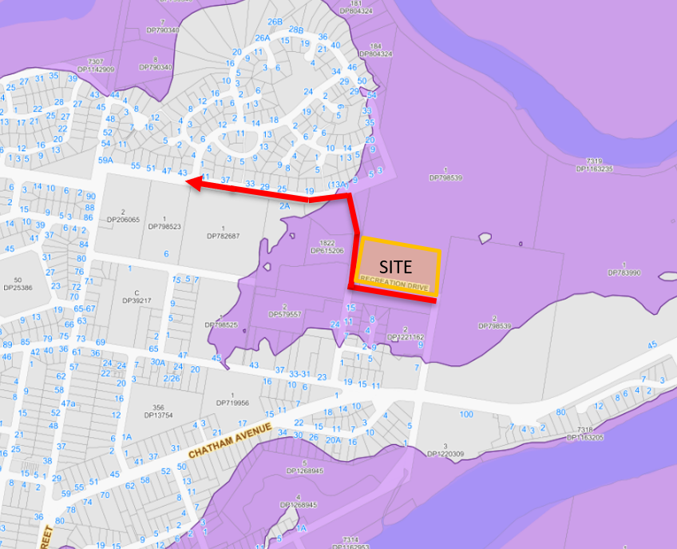

Evacuation coordinator:
Where are you evacuating?  (Location) | When will you evacuate?  (trigger) | How will you transport evacuees?
West from the site, along Recreation Drive, north along Gipps Street and then west along Bushland Drive | If flooding is moving towards the site | By foot
If there is no imminent risk of flooding, Rec Grounds on the corner of Bligh St | When warning is given by BOM | By car if possible otherwise by foot
EMERGENCY CONTACTS
Your emergency contacts can include Emergency Services, doctors set. It should also include staff members' family contacts, suppliers, customers and service companies such as electricians and plumbers.
NAME | PHONE | MOBILE
Police/Ambulance/Fire | 000
Local Police Station
SES (for life threatening situations call 000) | 132500
Graham Bourke | 0411203727

REVIEW OF PLAN
Ongoing review and updating of emergency management measures will occur as needed and will:
  - be developed in consultation with Council, NSW Police Force, Fire and Rescue NSW or the NSW Rural Fire Service and NSW Ambulance
  - identify the person or role that is responsible for managing the emergency response at the site
  - be distributed to all agencies and relevant parties
  - include the chain of command should an emergency occur
  - have clear instructions on how the person in charge will be contacted should an emergency occur.

